Source code:--

=>

import pandas as pd

import matplotlib.pyplot as plt

df = pd.read_csv('cars1111.csv')

plt.figure(figsize=(20,10))

plt.xlabel('COUNTRIES')

plt.ylabel('AMOUNT OF PRODUCTION')

plt.annotate('The highest production', xy=(0, 850), xytext=(3, 850),

arrowprops=dict(facecolor='black', shrink=0.05),

)

plt.annotate('The lowest production', xy=(400, 0), xytext=(400, 8),

arrowprops=dict(facecolor='black', shrink=0.05),

)

df_counts = df['Origin'].value_counts()

df_counts.plot(kind = 'bar')

plt.legend()

df_counts

OUTPUT:-

US 902

Europe 317

Japan 299

China 87

India 83

UK 73

Dubai 70

South Africa 56

Iceland 53

Pakistan 53

Brazil 34

Grrenland 30

Greenland 21

Srilanka 11

SouthAfrica 5

Name: Origin, dtype: int64

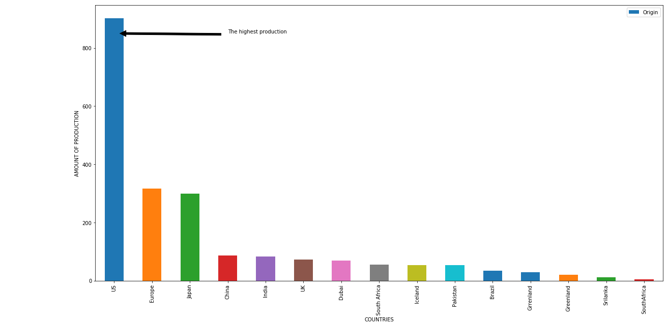

=>

import pandas as pd

import numpy as np

import matplotlib.pyplot as plt

plt.figure(figsize=(20,10))

df = pd.read_csv('E:/cars1.csv')

plt.title('Production in specific year')

plt.xlabel('YEAR OF PRODUCTION')

plt.ylabel('AMOUNT OF PRODUCTION')

Year_count = df['Year'].value_counts()

Year_count.plot(kind = 'bar')

Year_count

OUTPUT:-

73.0 199

78.0 197

77.0 176

82.0 176

76.0 168

81.0 166

71.0 148

75.0 148

74.0 147

79.0 146

72.0 143

80.0 142

70.0 138

Name: Year, dtype: int64

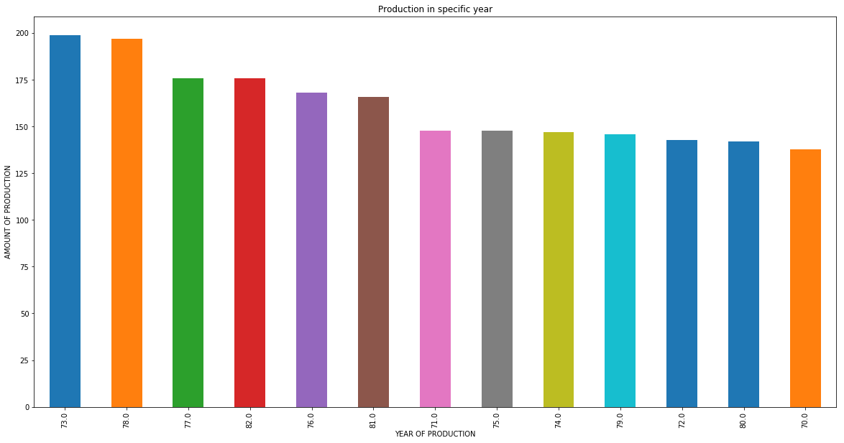

Pie analysis:-

import pandas as pd

import numpy as np

import matplotlib.pyplot as plt

plt.figure(figsize=(20,10))

df = pd.read_csv('E:/cars1.csv')

plt.title('Production in specific year')

plt.xlabel('YEAR OF PRODUCTION')

plt.ylabel('AMOUNT OF PRODUCTION')

Year_count = df['Year'].value_counts()

Year_count.plot(kind = 'Pie')

Year_count

OUTPUT:-

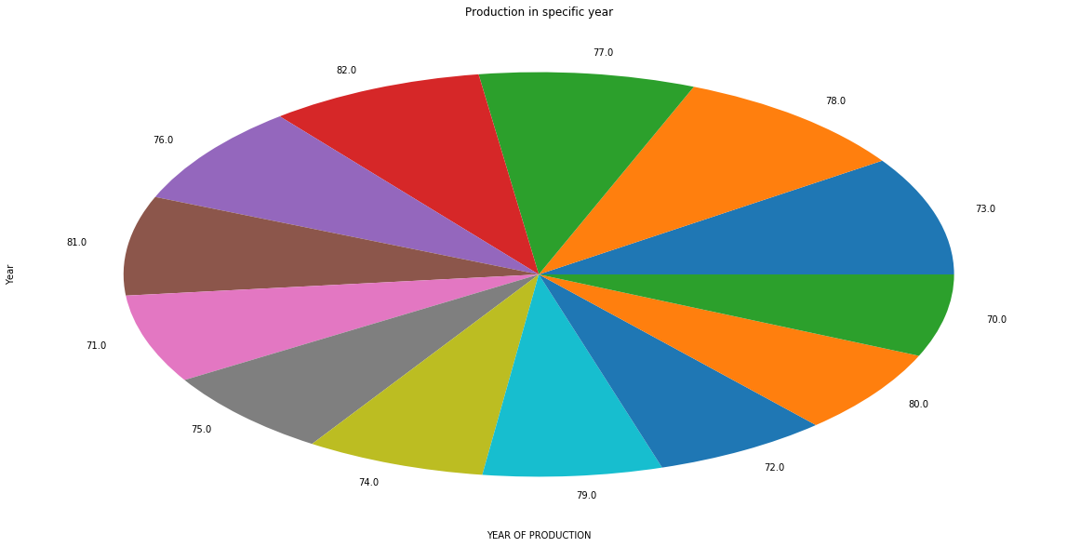

=>

plt.figure(figsize=(20,10))

df1 = df[0:200]

y = df1['MPG']

x = list(range(200))

plt.scatter(x, y, label='Bar')

#plt.plot(x, x**2, label='quadratic')

#plt.plot(x, x**3, label='cubic')

plt.xlabel('First 50 cars')

plt.ylabel('Displacement')

plt.title("Analysis of 1st 50 cars")

plt.legend()

plt.show()

OUTPUT:-

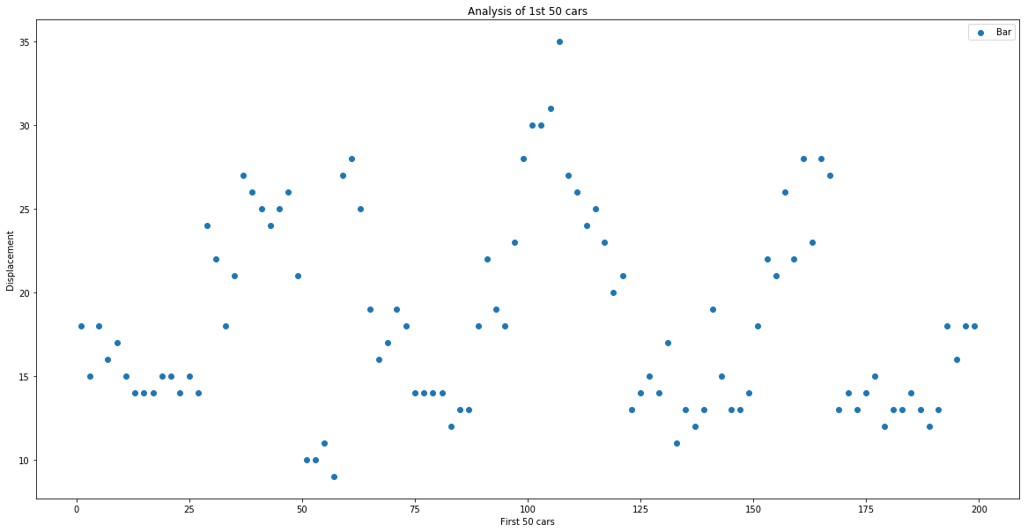

=>

plt.figure(figsize=(20,10))

df1 = df[0:200]

y = df1['Acceleration']

x = list(range(200))

plt.scatter(x, y, label='Bar')

#plt.plot(x, x**2, label='quadratic')

#plt.plot(x, x**3, label='cubic')

plt.xlabel('First 100 cars')

plt.ylabel('acceleration')

plt.title("Analysis of 1st 100 cars")

plt.legend()

plt.show()

OUTPUT:-

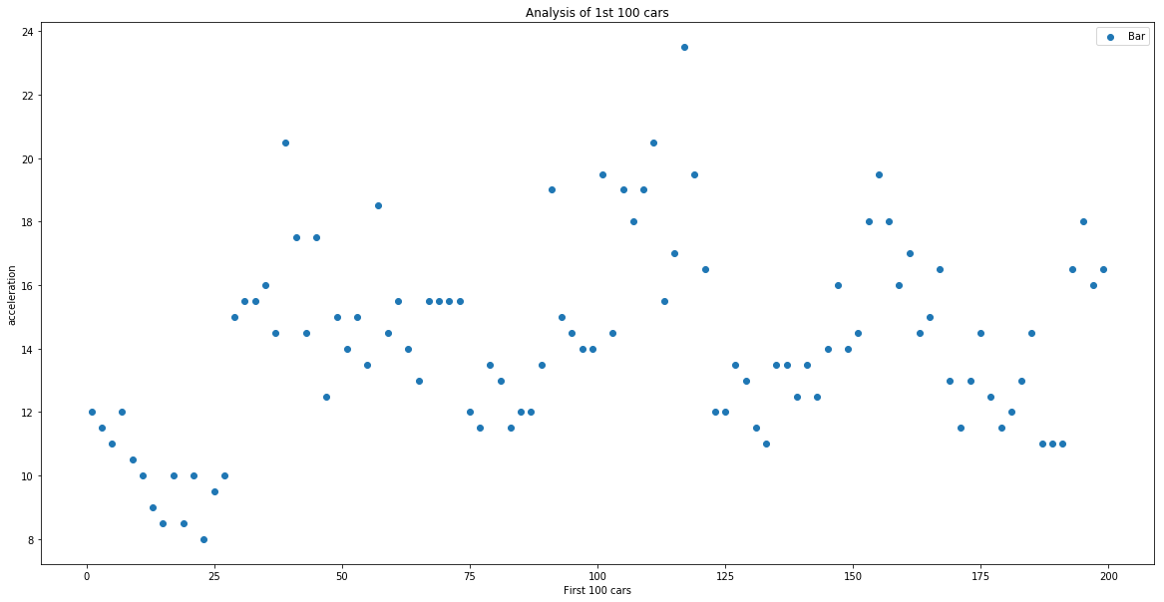

=>

x = df['Year']

y = df['Acceleration']

plt.xlabel('Year')

plt.ylabel('acceleration')

plt.title("Acceleration vs Year")

plt.bar(x,y)

plt.show()

OUTPUT:-  
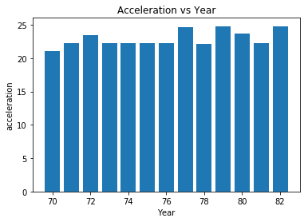

=>

x = df['Year']

y = df['Horsepower']

plt.xlabel('Year')

plt.ylabel('Horsepower')

plt.title("Horsepower vs Year")

plt.bar(x,y)

plt.show()

OUTPUT:-

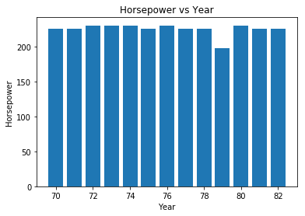

=>

x = df['Year']

y = df['MPG']

plt.xlabel('Year')

plt.ylabel('MPG')

plt.title("MPG vs Year")

plt.bar(x,y)

plt.show()

OUTPUT:-

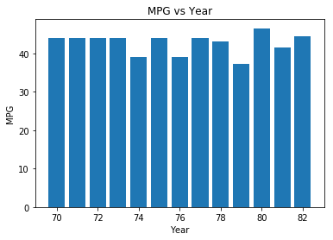

=>

plt.figure(figsize=(20,10))

x = df['Weight']

y = df['Acceleration']

plt.xlabel('Weight')

plt.ylabel('acceleration')

plt.title("Acceleration vs Weight")

plt.bar(x,y)

plt.show()

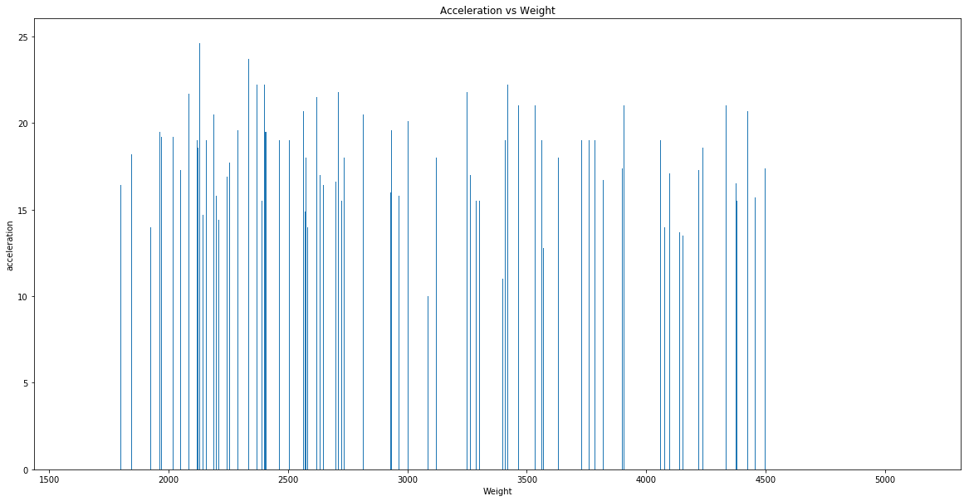

=>

plt.figure(figsize=(20,10))

x = df['Weight']

y = df['MPG']

plt.xlabel('Weight')

plt.ylabel('MPG')

plt.title("MPG vs Weight")

plt.bar(x,y)

plt.show()

OUTPUT:-

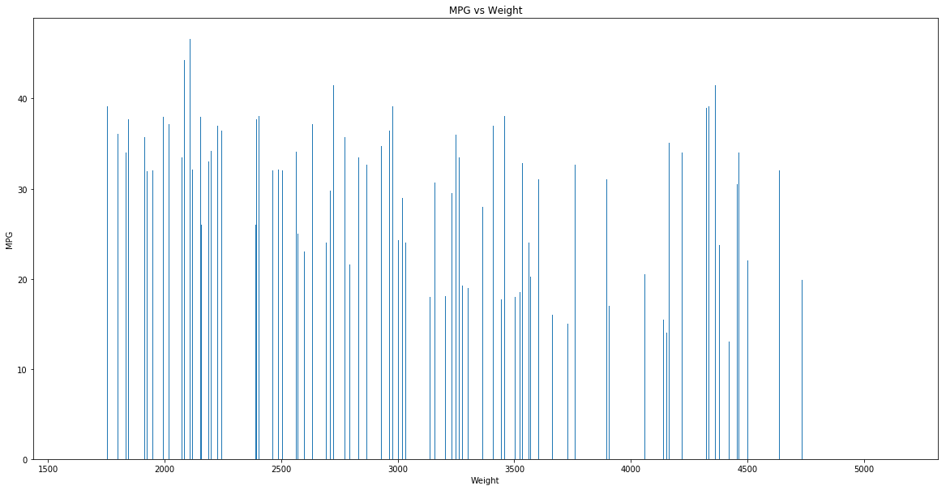

=>

plt.figure(figsize=(20,10))

df = pd.read_csv('E:/cars1.csv')

plt.title('No of Cylinders')

plt.xlabel('YEAR OF PRODUCTION')

plt.ylabel('AMOUNT OF PRODUCTION')

plt.annotate('The highest no of cylinders', xy=(0, 850), xytext=(3, 850),

arrowprops=dict(facecolor='black', shrink=0.05),

)

Year_count = df['Cylinders'].value_counts()

Year_count.plot(kind = 'bar')

OUTPUT:-

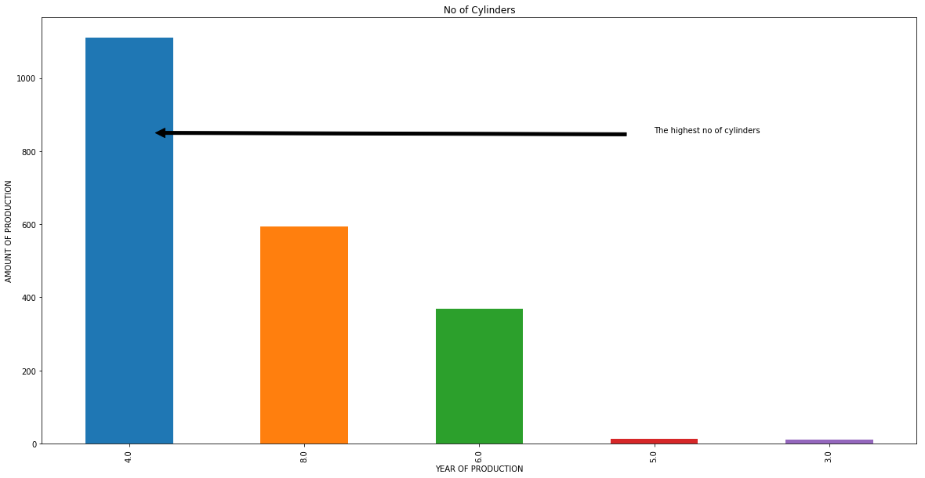

Pie analysis:-

plt.figure(figsize=(20,10))

df = pd.read_csv('cars1111.csv')

plt.xlabel('YEAR OF PRODUCTION')

plt.ylabel('AMOUNT OF PRODUCTION')

Year_count = df['Cylinders'].value_counts()

Year_count.plot(kind = 'pie')

OUTPUT:-

